Experiment no.:08 Keerthika.K-241901046
Collecting Email Evidence in Victim PC
Aim
To collect email evidence from a victim PC using DumpIt and Bulk Extractor Viewer.
Procedure
- Use the DumpIt tool to capture the RAM of the victim PC as the first step in collecting email evidence.
- DumpIt is used to generate a physical memory dump of Windows machines and supports both 32-bit and 64-bit systems.
- Run the DumpIt.exe file.
- Enter Y when prompted to proceed with memory acquisition.
- The raw memory dump file with the .RAW extension will be generated and saved in the same directory.
- Download Bulk Extractor Viewer from GitHub and install it on the system.
- Open Bulk Extractor Viewer and select the option to generate a report.
- Select the memory dump image file created using DumpIt.
- Choose an output folder for the report.
- Click Start Bulk Extractor to begin processing the selected dump file.
- After processing, open email.txt to examine the email addresses identified in the collected data.
- Open email_histogram.txt to examine the email-related histogram information.
- Record the observations for forensic investigation.
Observation
DumpIt generates a raw physical memory dump of a Windows system. Bulk Extractor Viewer processes the dump and generates a report containing extracted information. The files email.txt and email_histogram.txt can be examined to identify email-related evidence present in the processed data.
Observation Table
S. No. | Particulars | Observation
1 | Tool Used for Memory Acquisition | DumpIt
2 | Memory Dump Format | .RAW
 | Analysis Tool | Bulk Extractor Viewer
4 | Input Evidence | Memory dump file
5 | Output File 1 | email.txt
6 | Output File 2 | email_histogram.txt
7 | Email Evidence | Record the details actually extracted
8 | Status | Record the actual processing result

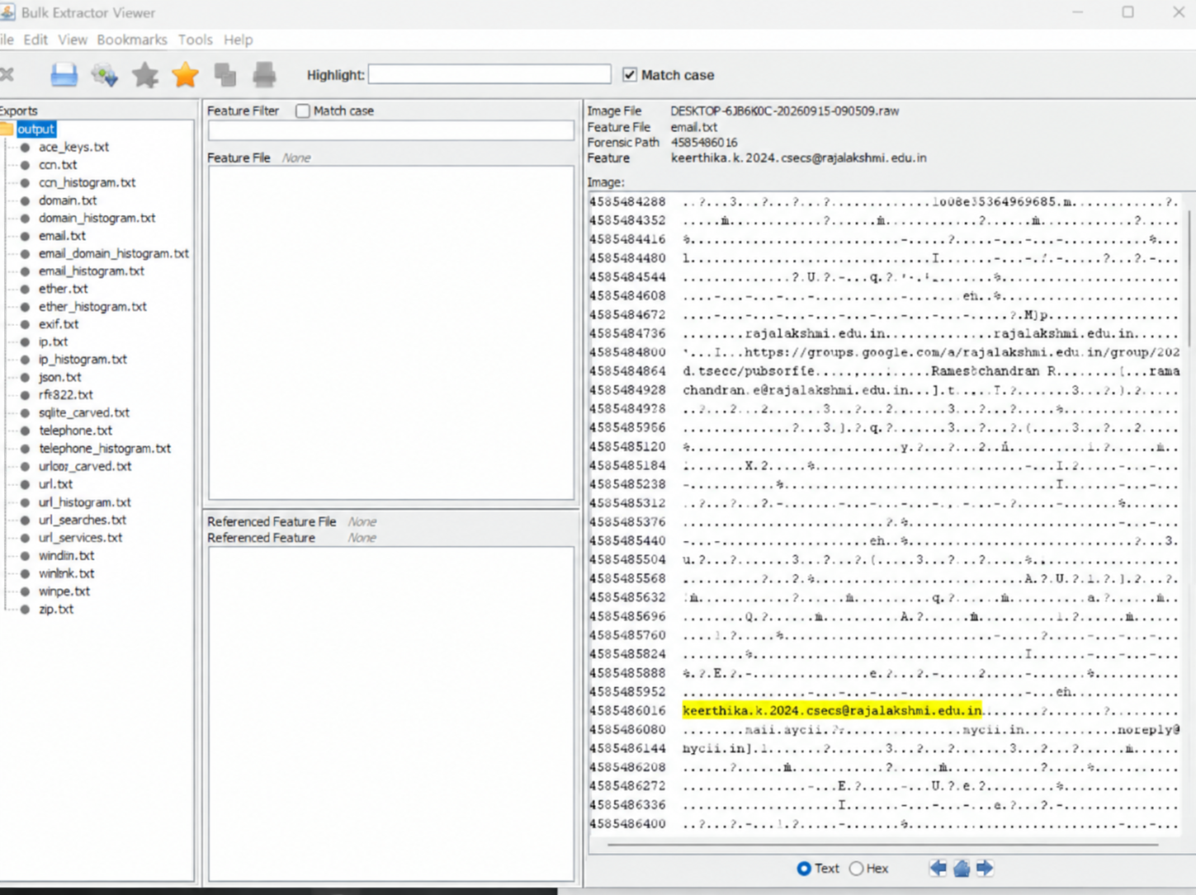

Result
Thus, the procedure for collecting and examining email-related evidence from a victim PC using DumpIt and Bulk Extractor Viewer was studied.

